Geometry: Unit 13, Lesson 13
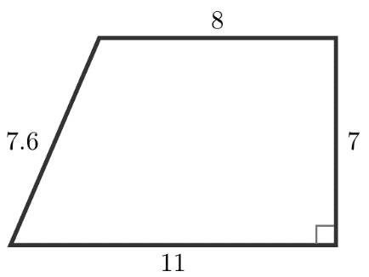
- A trapezoid is shown, with lengths marked on the figure. The area of the trapezoid can be found by evaluating the expression $\frac{1}{2} ∙\underline{\left(a\right)} (\underline{\left(b\right)}+\underline{\left(c\right)})$. What is the value of $\left(a\right)$? What is the expression for $\left(b\right)+\left(c\right)$?
$7, 8+11, 11+8, \left(8+11\right), \left(11+8\right), 19, \left(19\right), \left(8\right)+(11$)

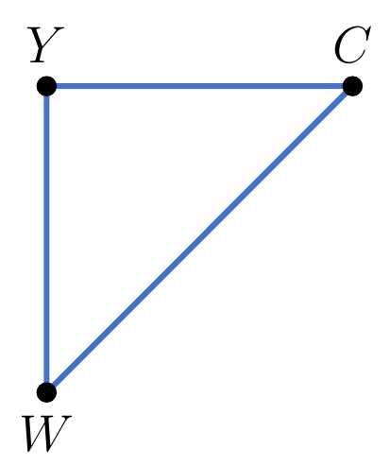

- Triangle $WCY$ is shown, where $m∠Y=90°$, $WC=6\sqrt{2}$, $CY=6$, and $WY=6$. What is the area of the triangle? What is the perimeter of the triangle?

$$18\sqrt{2} square units, 12+6\sqrt{2} units$$

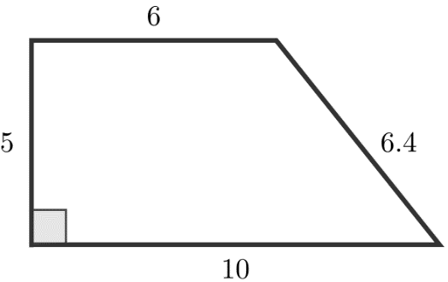
A trapezoid is shown with lengths marked on the figure. Write an expression that can be used to find the area of the trapezoid.

$$\frac{1}{2} ∙ 5 ∙(6+10)$$

